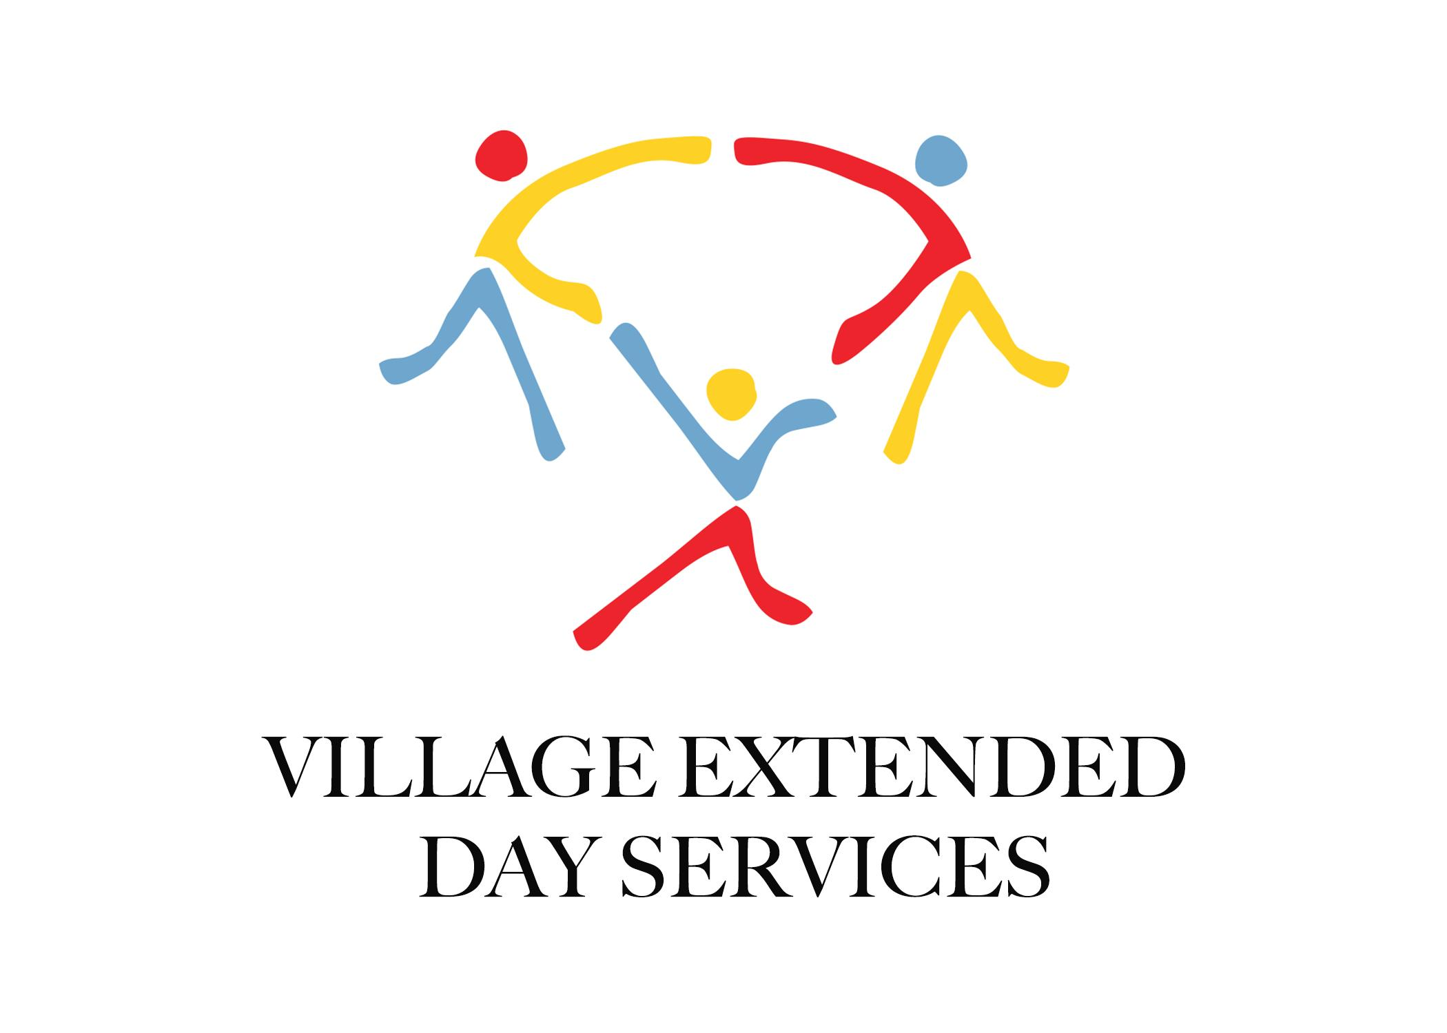

Dear Parents,

We hope you are doing well and are staying healthy. We are already planning for the
next school year and hope that it will be a smoother, safer and fun filled year for all the
children.

Our plan is to start registration for the Fall Extended Day program beginning on March
14th, 2022, beginning with our students who are already enrolled and attending
Extended Day. From March 14th-31st, there will be an early bird registration with a
discounted fee of $60 per child or $100 for two or more children. You can pay that on
Tuition Express if you would like, but please send a quick email to
donna@villageextendedday.com so that we know you will be doing that and can credit it
appropriately in our accounts. You can also drop off a check with us at Extended Day for
the registration fee when you pick up your child.

Starting April 1st, the regular fee for registration will be $75 per child or $125 for two or
more children. At that time, we will be open registration to all the students at Freedom Crossing Academy as well as incoming kindergarten students and new students.
If you have any questions at any time, please let us know, and we would be more than
happy to help you out.

Best wishes,

Donna Belz- Freedom Crossing Academy Extended Day Director
Rachel Sledge- Executive Director

